Handle Frame in Playwright
URL-https://ui.vision/demo/webtest/frames/
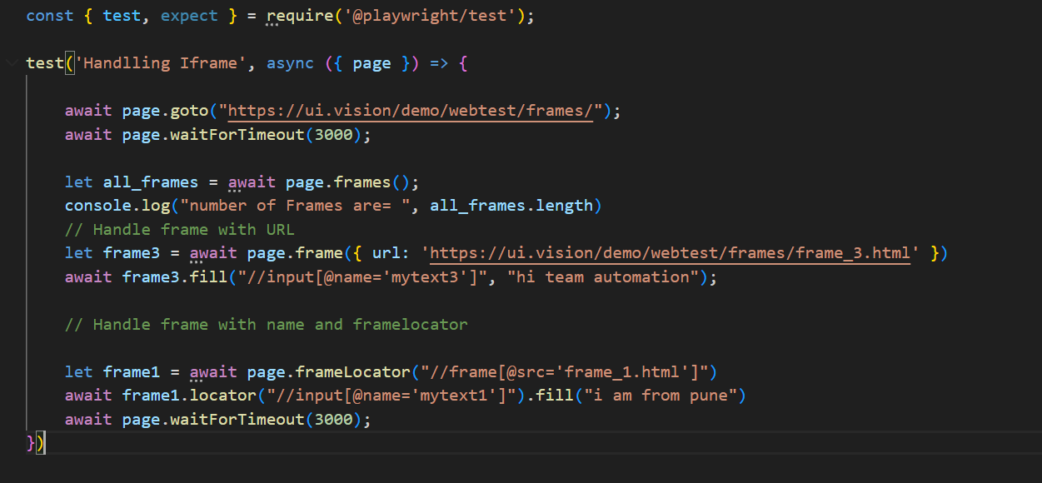
Single File Upload
URL 1-https://automationtesting.co.uk/fileupload.html
URL2-https://davidwalsh.name/demo/multiple-file-upload.php

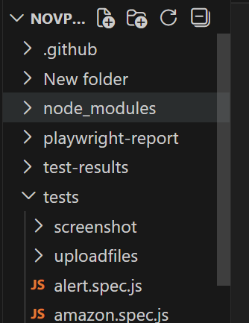
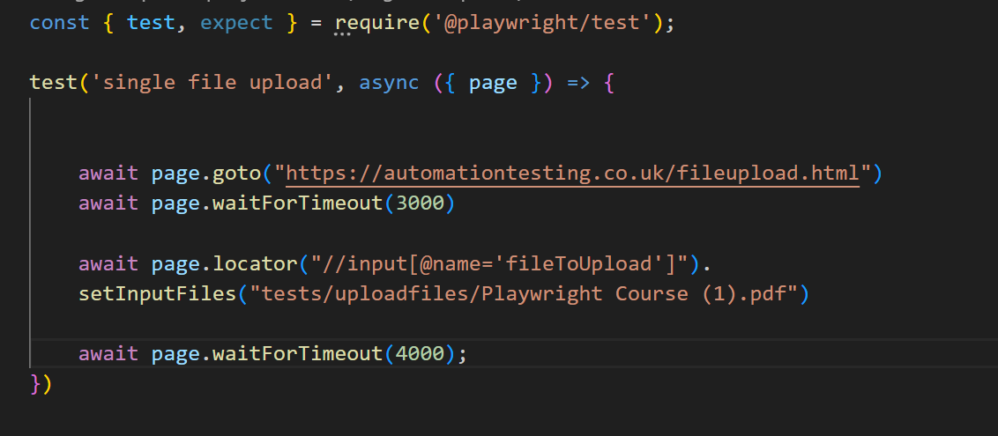
Multiple File Upload-
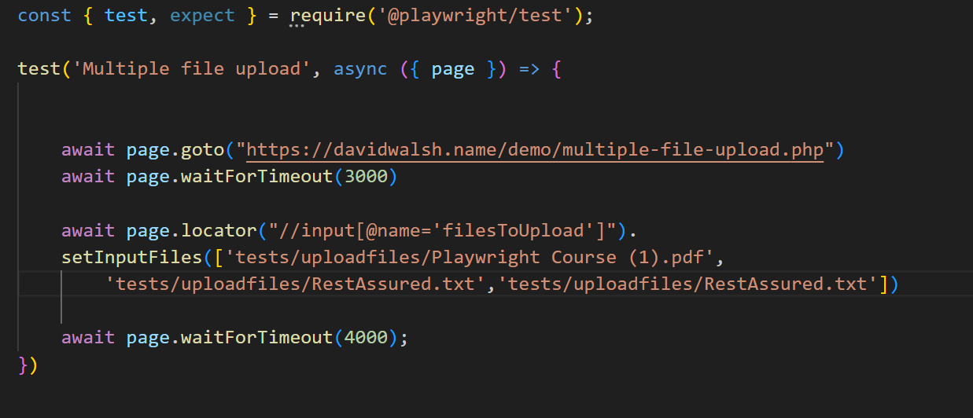
Retries
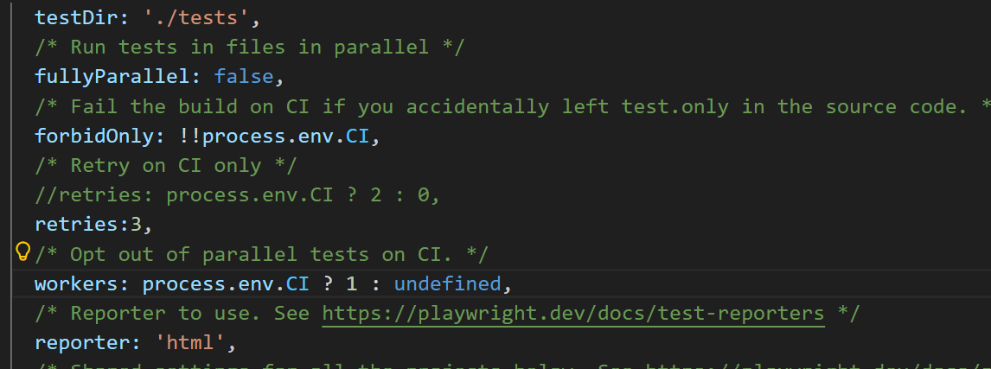

Thank you

